RideIQ
How We Built It - A Step-by-Step Guide
From an idea, to an Android app, to a live cloud service with automated deployment
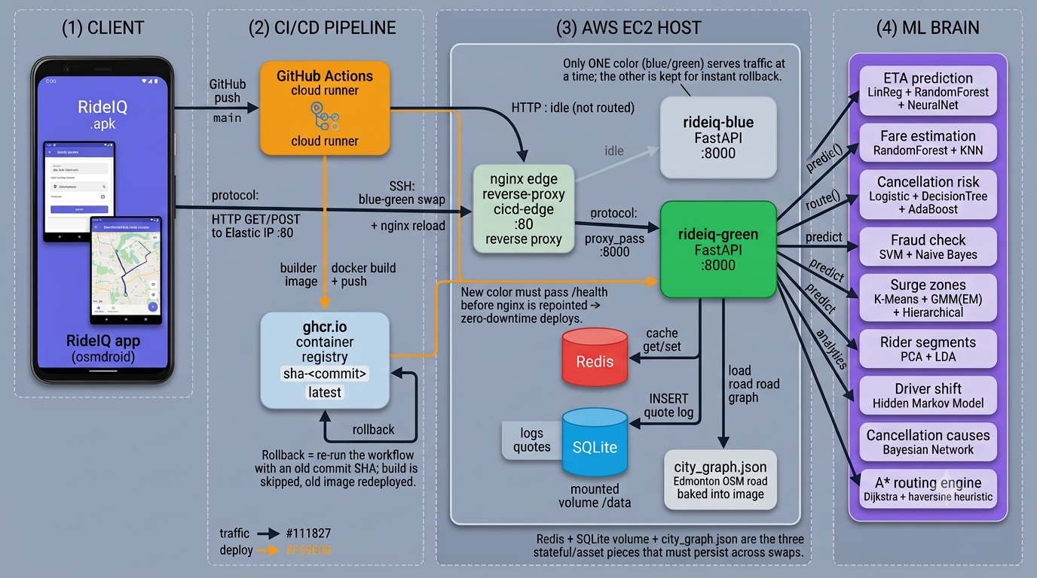
The finished system at a glance - every box in this diagram is explained in this guide.

1. What is RideIQ?
RideIQ is a ride-hailing app - think of a simplified Uber. A rider opens the app, sees a map of Edmonton, sets a pickup and a drop-off, and gets a live route with an estimated time of arrival (ETA), a fare, and turn-by-turn voice navigation. Behind the scenes, a “brain” on a server does the hard work: it predicts the ETA and fare with machine-learning models, finds the best road route, and even estimates how likely the ride is to be cancelled.
What makes it special for learning: everything is built from scratch and self-hosted. There is no paid Google Maps API - the maps use free OpenStreetMap data, and the routing is solved by our own code. And it is deployed the way real companies deploy software: automatically, with zero downtime, and with a one-click undo button. This guide walks through how all of that was built, in the order it was built, so you can follow the story and understand how the pieces connect.

What you will understand by the end
- How a mobile app and a server “talk” to each other over the internet.
- What Docker is and why we put the app “in a box.”
- What CI/CD means and how a single push ships new code to a live server.
- What blue-green deployment and rollback are, and why they keep the app safe.
- How live GPS navigation with spoken directions actually works.

2. The Build Order (the map of our journey)
We did not build everything at once. We built one piece, made sure it worked, then added the next. This is the single most important habit in the whole project. Here is the order we followed:
- The backend brain - A Python server that computes ETAs, fares, routes and more using machine learning.
- Package it with Docker - Wrap the backend in a container so it runs the same everywhere.
- The Android app - A phone app with a map and a quote screen.
- Connect app and backend - Point the app at the server so real data flows.
- Put it online (AWS EC2) - Run the backend on a cloud computer with a fixed public address.
- Automate deploys (CI/CD) - Every code push builds and ships the app automatically.
- Zero-downtime + rollback - Blue-green deployment so a bad update can never take the app down.
- Grow features one by one - My-location, addresses, live voice navigation, street names.
The rest of this guide takes each stage in turn and answers three questions: what we built, why we made that choice, and how it connects to the rest of the system.

3. The Stages, Explained

Stage 1 - The backend “brain” (FastAPI + Python)
What we built: A web service (an API) written in Python with FastAPI. It exposes simple web addresses (endpoints) like /quote, /route-latlon and /health. When the app calls /quote with a distance and time, the server runs 15 machine-learning models and returns an ETA, a fare, and a cancellation risk. It also holds an A* routing engine that finds the shortest driving path over Edmonton's real roads (downloaded once from free OpenStreetMap data).
Why FastAPI + Python: Python is the language of machine learning, so the models (scikit-learn) live naturally beside the API. FastAPI is fast, and it auto-generates an interactive documentation page at /docs so you can test every endpoint in a browser without writing any app code.
How it connects: This server is the single source of truth. The phone app never does the heavy thinking itself - it asks the backend and displays the answer. Everything else in this guide exists to run this brain reliably and let the app reach it.

Stage 2 - Packaging with Docker
What we built: A Dockerfile - a short recipe that turns the backend and all its Python libraries into a single portable image. Running that image gives you a container: the app, boxed up with everything it needs.
Why Docker: “It works on my machine” is a classic problem. A container removes it: the same image runs identically on your laptop, on a teammate's machine, and on the cloud server. No “wrong Python version” surprises.
How it connects: The image is the unit we ship. Our automated pipeline builds this image and sends it to the cloud server, which runs it as a container. Think of the image as a sealed meal-kit and the container as the cooked meal.

Stage 3 - The Android app
What we built: A Java Android app with two screens: a quote screen (enter trip details, get ETA/fare/analytics) and a map screen using osmdroid, which draws free OpenStreetMap tiles. The app talks to the backend using Retrofit, a library that turns web responses into Java objects.
Why osmdroid (not Google Maps): osmdroid needs no API key and no billing account - it is completely free and open. That keeps the whole project self-contained and teachable, and it matches our “no paid API” goal.
How it connects: The app is the face of the system. Every button (“Get quote,” “route,” “start trip”) becomes a call to one of the backend's endpoints.

Stage 4 - Connecting the app to the backend
What we did: Set one line in the app (BASE_URL) to the address of the server. During early testing this was a local address; for the real app it is the server's public web address.
Why it matters: This single line is the bridge between the two halves of the project. Get it right and the app lights up with real data; get it wrong and every screen says “can't reach server.”
How it connects: The app sends an ordinary web request (HTTP) to the server's front door (see Stage 5), which passes it to the running backend container.

Stage 5 - Putting it online (AWS EC2 + a public address)
What we built: We rented a small cloud computer (an AWS EC2 virtual machine) and gave it a fixed public address (an Elastic IP / public DNS name). In front of the app container we run nginx, a reverse proxy, listening on the standard web port 80.
Why a reverse proxy: nginx is the single, stable front door. The app container can be replaced behind it at any time, but the public address never changes. It also means we expose only port 80 to the world and keep everything else private.
How it connects: Phone -> public address -> nginx (port 80) -> the live app container (port 8000). The app never needs to know which container is running; it just knows the front door.

Stage 6 - Automating deployment (CI/CD with GitHub Actions)
What we built: A pipeline that runs automatically whenever we push code to the main branch. It (1) builds the Docker image in the cloud, (2) pushes it to a container registry (ghcr.io), and (3) logs into the EC2 server over SSH and updates the running app.
Why CI/CD: CI/CD stands for Continuous Integration / Continuous Delivery. It replaces slow, error-prone manual steps with one reliable, repeatable process. You push code; the robot does the rest, the same way every time.
How it connects: This is the conveyor belt that carries your code from your laptop all the way to the live server without you touching the server by hand.

Stage 7 - Zero-downtime and safety (blue-green + rollback)

Blue and green are two copies of the app. Only one serves traffic at a time; the other is the safety net.
What we built: The deploy runs a blue-green swap. The new version starts up next to the old one (as the other “color”). We health-check the new one first; only when it reports healthy does nginx switch traffic to it, and the old one is retired. If the new version fails to start, traffic never switches and users notice nothing.
Why blue-green + rollback: It means deploys have zero downtime and a bad update cannot take the site down. And because every version is a tagged image, rollback is simply redeploying an older tag - a one-click undo.
How it connects: This is the safety system wrapped around Stage 6. It is what lets us ship new features confidently, several times a day if we want.

Stage 8 - Growing the app, one feature at a time
With the pipeline in place, each new feature was a small, self-contained change that we shipped and tested before starting the next:
- My location: show the driver's live GPS dot on the map (using free osmdroid location, no Google key).
- Automatic addresses: pickup defaults to your location and both pins show their real street address (reverse geocoding via free OpenStreetMap Nominatim).
- Live turn-by-turn navigation: a “Start trip” mode where the map follows your GPS and each turn is spoken aloud and shown on screen (“In 200 meters, turn left”), announcing arrival and rerouting if you drift off course.
- Street names: the backend now includes real street names in each instruction (“Turn left onto 109 Street”).
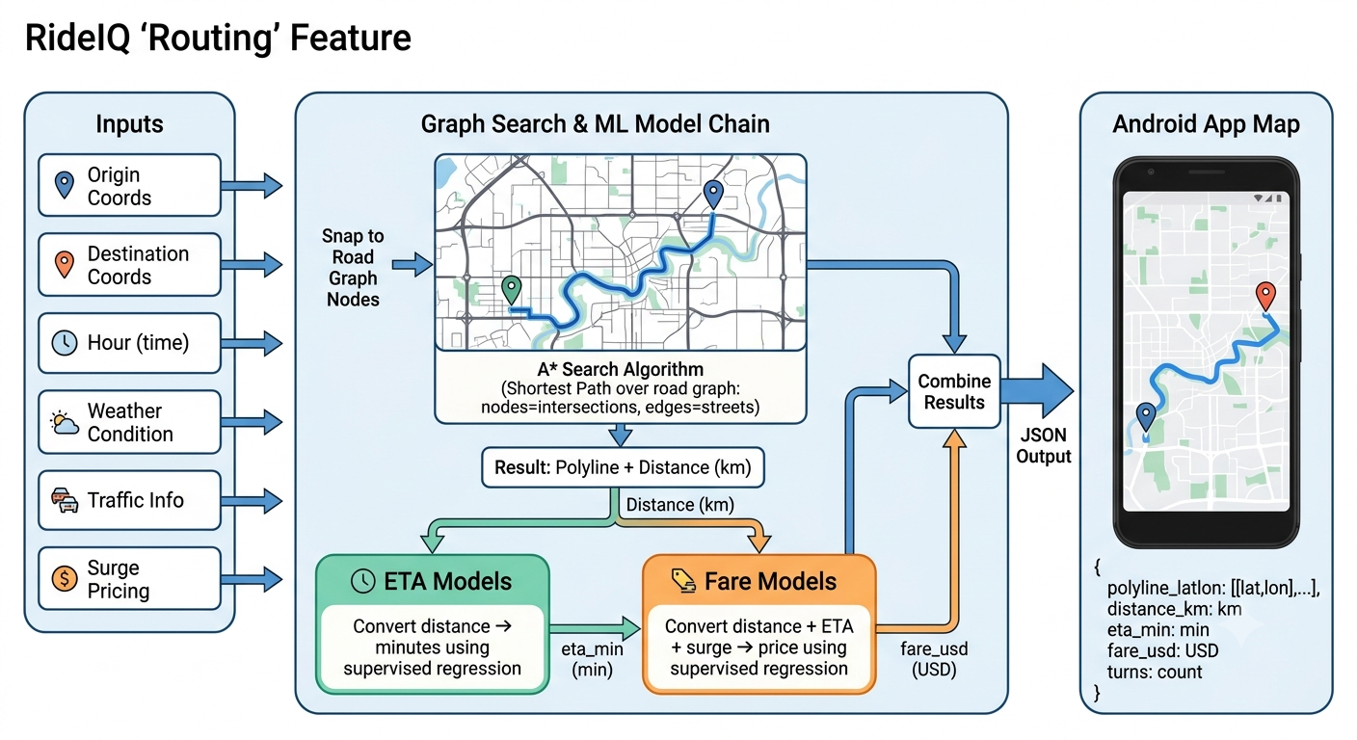
How routing + navigation works: find the road path, then price it and guide the driver turn by turn.

4. How It All Connects (one request's journey)
Here is what happens the moment a rider taps “Get quote” or drives a route:
- The phone sends a web request (HTTP) to the public address of the server.
- nginx, the front door on port 80, receives it and passes it to the live app container (port 8000).
- The FastAPI backend runs the right logic: ML models for ETA/fare, or the A* engine for a route, checking its Redis cache first.
- The answer travels back the same way - container -> nginx -> phone - and the app draws it on screen or speaks the next turn.
- Every quote is also saved to a small database (SQLite) so the system keeps a history.

5. Key Ideas, in Plain Words
Term | What it means
API | A set of web addresses a program can call to ask for data or actions. Our app calls the backend's API.
Container / Docker | A sealed box holding an app and everything it needs, so it runs the same everywhere.
Image / Registry | An image is the sealed box; a registry (ghcr.io) is the shelf we store and fetch images from.
CI/CD | Automation that builds and ships your code every time you push it - no manual steps.
Blue-green deploy | Run two copies; switch traffic to the new one only after it passes a health check. Zero downtime.
Rollback | Undo a bad release by redeploying an older, known-good image tag.
Reverse proxy (nginx) | The stable public front door that forwards requests to whichever app container is live.
Reverse geocoding | Turning GPS coordinates into a human street address.
A* routing | An efficient algorithm that finds the shortest path across a map of roads.
Health check | A quick “are you okay?” ping the system uses to decide if a new version is safe to use.

6. The Technology, and Why
Technology | Why we chose it
FastAPI (Python) | Fast API framework that sits naturally next to the ML models and auto-generates test docs.
scikit-learn | Trains the 15 machine-learning models behind ETA, fare, surge, fraud and more.
osmdroid + OpenStreetMap | Free, key-free maps and tiles for the Android app - no Google billing.
Retrofit (Android) | Cleanly turns backend JSON responses into Java objects the app can use.
Docker | Makes the backend portable and reproducible across every machine.
GitHub Actions | Runs the CI/CD pipeline - build, push, deploy - automatically on each push.
nginx | The reverse-proxy front door enabling the blue-green swap and a stable public address.
AWS EC2 | The cloud computer that hosts the live backend with a fixed public IP.
Redis + SQLite | Redis caches repeated answers for speed; SQLite stores a history of quotes.

7. What Comes Next
The foundation is deliberately simple so it can grow. Sensible next steps, each shippable on its own through the same pipeline:
- HTTPS + a domain name, so the app runs over secure, encrypted connections.
- A managed database (Postgres) to replace SQLite once there are many users.
- Live location sharing and audio transcription features.
- Monitoring dashboards so we can see the system's health at a glance.
The lesson that ties it all together: build one small thing, make it work, ship it safely, then add the next. That single habit is what turns a class project into something that behaves like real production software.

